**Control Statements**

**We can control the program flow**

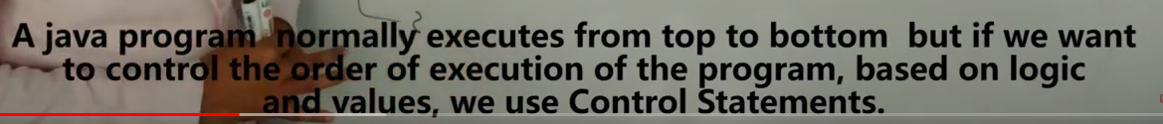

* ***If***
* ***If else***
* ***if else if***
* ***nested if***
* ***switch***

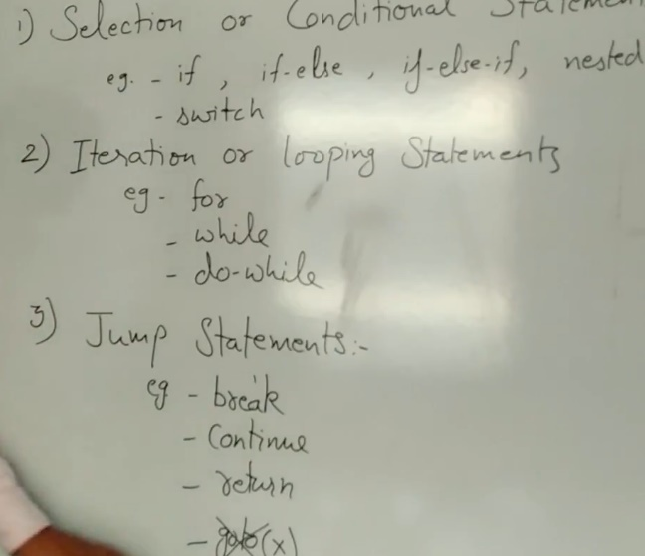



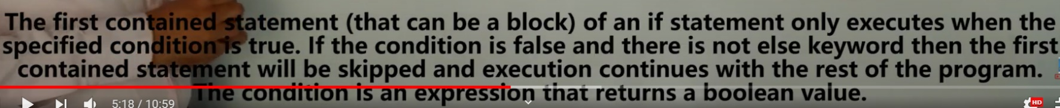

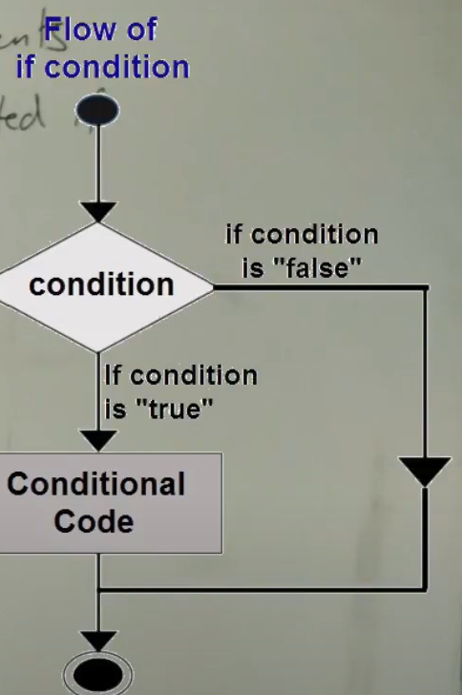

**If else**

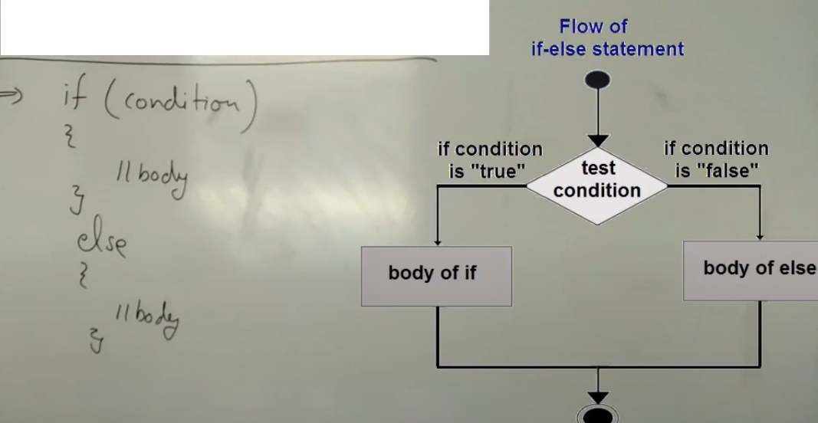



If else if

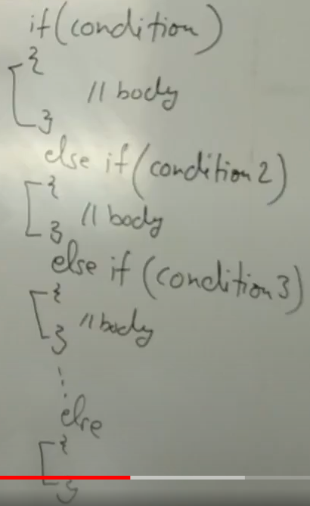



**Nested if…**



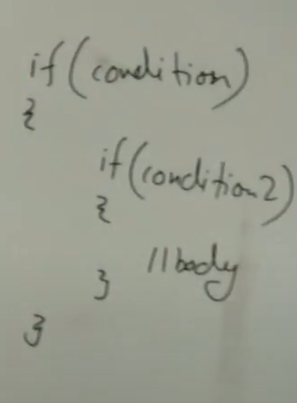

**Switch**



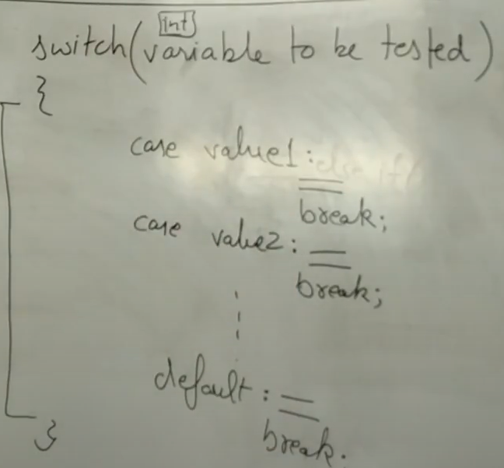

**Iteration/loop statements**



**For loop:condition—body---+=/--**

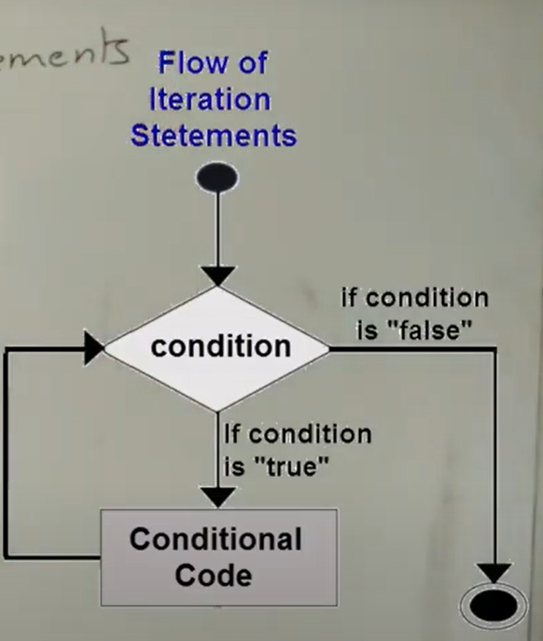

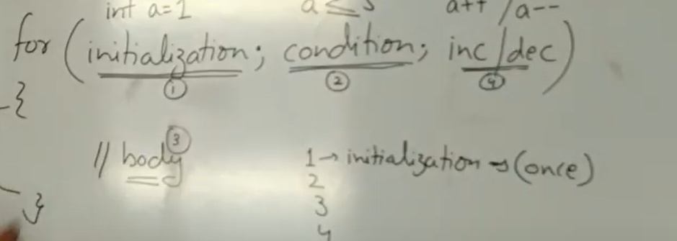

**While**

**While—condition{body}**



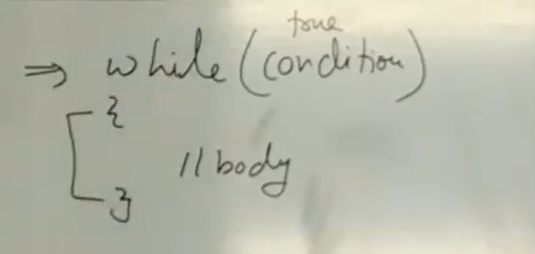

***Do While loop***

*Do body while-condition-here 1st body execute---then check the condition…if its true again execute do body*

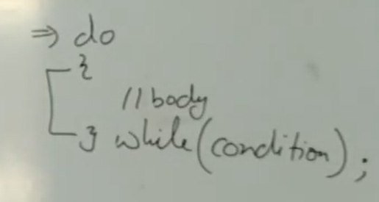

**Jump statements**

